

**COMSATS UNIVERSITY ISLAMABAD, LAHORE CAMPUS**

**Project Name:**

**Bus Ticket Booking System**

**Subject:**

**Object Oriented Programing**

**Submitted to:**

**Sir Shahid Bhatti**

**Submitted by:**

**HAMDAN ZULFIQAR – (SP24-BSE-032)**

**MUDDASAR ALI GHAFOOR – (SP24-BSE-062)**

**Submission Date: December 20, 2024**

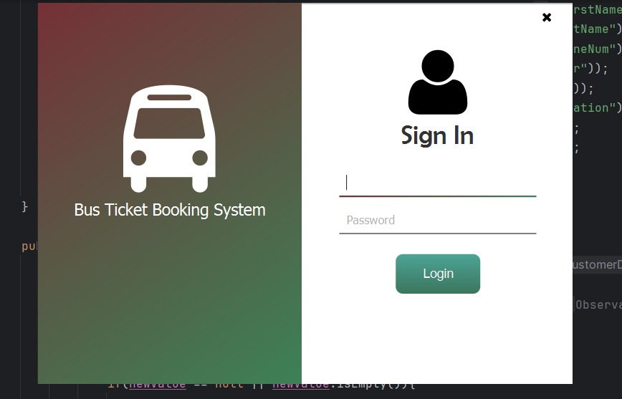**Login Page:**

**Login page for login to Bus Ticket Booking System Application. This page requires a username and password to login to the dashboard of the application.**

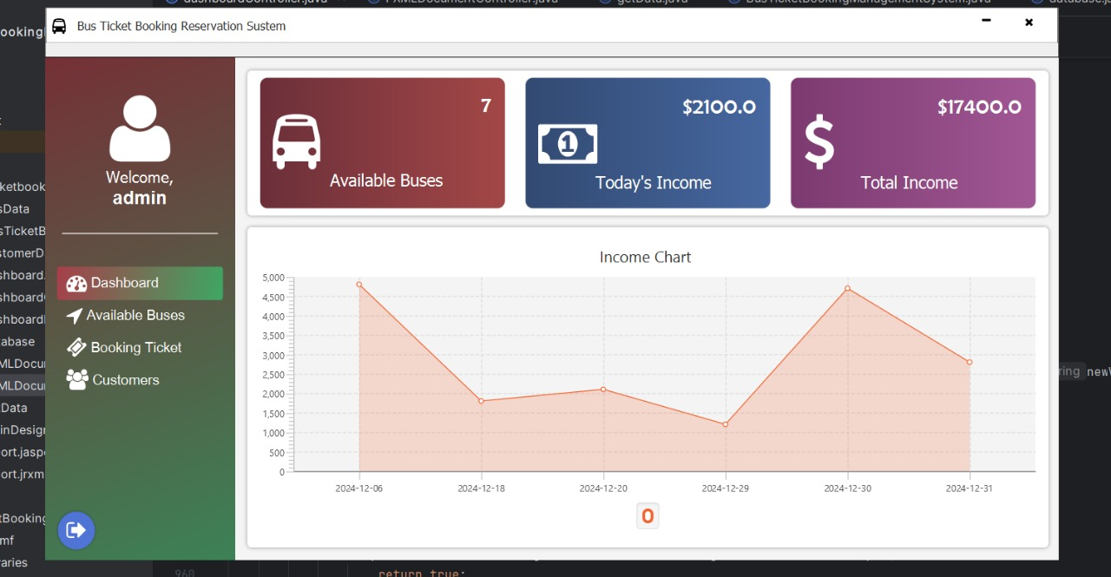**Dashboard Page:**

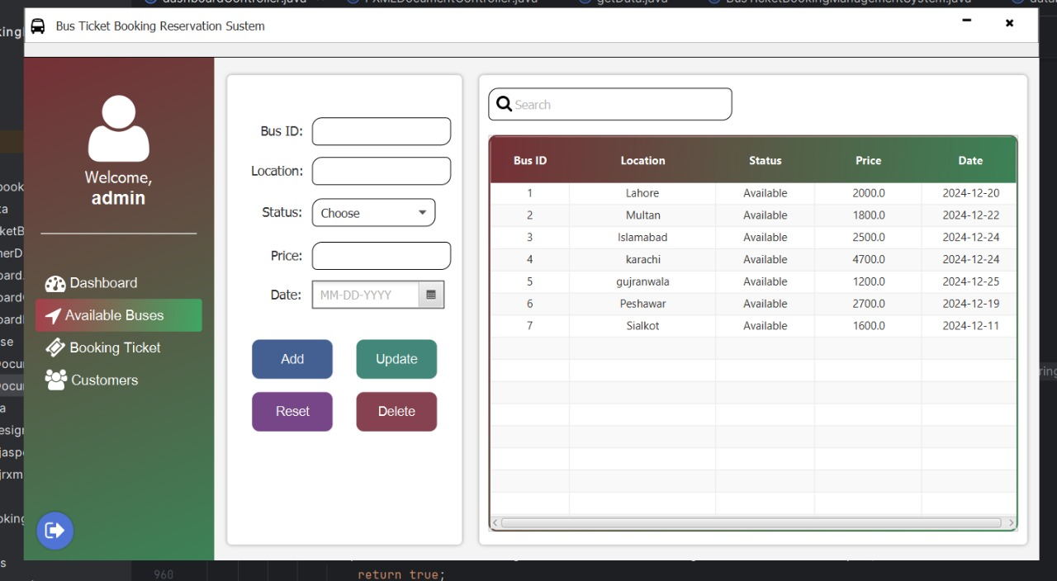**Available Buses Page:**

**Booking Ticket Page:**

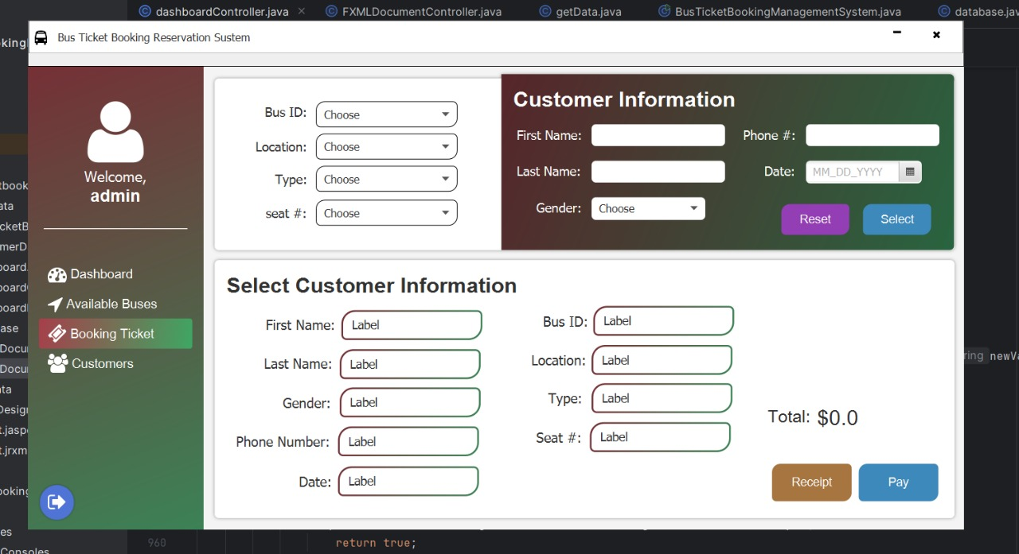

**Customers Page:**

